Assignment 2  
Machine Learning as a Service

short line

Monali Patil

Student ID: 14370946  
10/10/2023

36120 - Advanced Machine Learning Application

Master of Data Science and Innovation

University of Technology of Sydney

Table of Contents

1. Executive Summary 2

2. Business Understanding 3

3. Data Understanding 4

4. Data Preparation 5

5. Modeling 9

6. Evaluation 13

7. Deployment 18

8. Conclusion 19

9. References 20

# 

|  |  |
| --- | --- |
| Project Repo: | https://github.com/MonaliPatil19/adv_mla_assignment2.git |
| API Servicing Repo: | https://github.com/MonaliPatil19/assignment2_api.git |
| Heroku API URL: | https://obscure-escarpment-15993-549ea5837663.herokuapp.com/docs |

# Executive Summary

**Project Overview:**

The project involves working with an American retail chain operating across California (CA), Texas (TX), and Wisconsin (WI) offering a diverse range of products, including hobbies, foods, and household items, across ten stores. This project aimed to develop and deploy two distinct machine learning models as API services to assist in business decisions related to sales revenue to achieve overall business profitability.

* + - 1. Predictive Model: To accurately predict sales revenue for individual items in specific stores for any given date for managing inventory levels, optimizing pricing strategies, and ensuring product availability.

1. Forecasting Model: To forecast the total sales revenue across all stores and items for the upcoming 7 days, commencing from the provided input date using a time series analysis algorithm allowing for better resource allocation, staffing decisions, and financial planning.

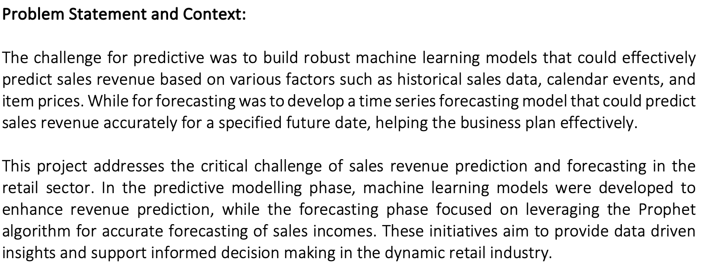

**Achieved Outcomes and Results:**

The project resulted in the development of predictive models using algorithms like XGBoost and Linear Regression. These models provided insights into revenue trends, contributing to better inventory management and pricing strategies. In addition, the project successfully implemented the Prophet algorithm to forecast sales revenue. It achieved low Mean Absolute Percentage Error (MAPE) and Root Mean Square Error (RMSE) scores, indicating accurate revenue predictions. This will aid the business in planning and decision-making.

In summary, the project involves predictive modelling for revenue prediction and Prophet algorithm-based forecasting to provide accurate future revenue estimates, contributing to improved business strategies in the retail industry.

# Business Understanding

This project primarily focuses on two key business use cases:

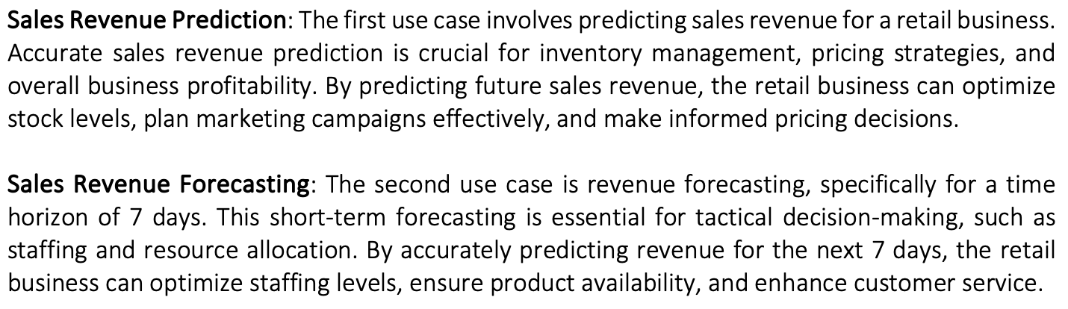

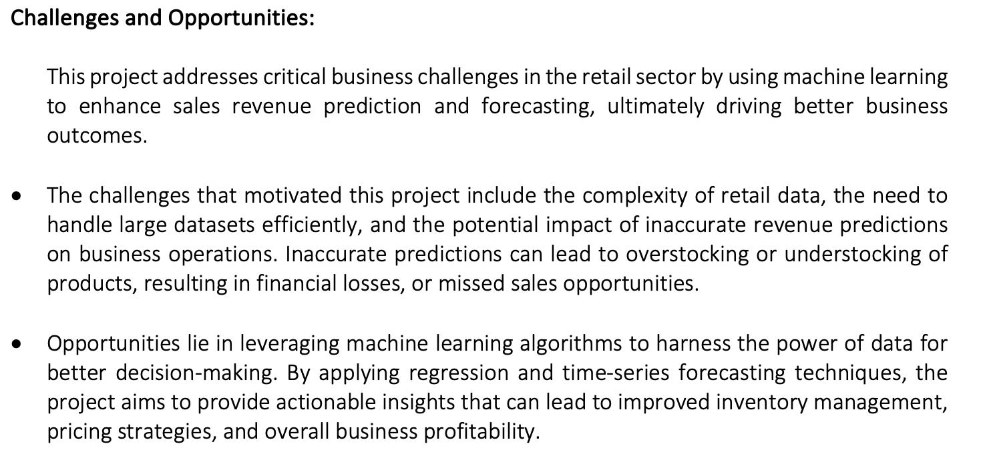

**Key Objectives:**

* Accurate Predictions: Develop a revenue prediction and forecasting model that provides precise predictions.
* User-Friendly Interface: Develop an intuitive interface for end users and stakeholders to access the model through an API.
* Scalability: Ensure the model's ability to handle real-time data for both prediction and forecasting.
* Privacy and Fairness: Define principles and guidelines for privacy and fairness.
* Ethical Data Handling and Bias Prevention: Ensure ethical treatment of the retailer's data and prevent bias.
* Stakeholder Collaboration: Collaborate closely with retail managers, pricing analysts, and domain experts.
* Ethical Guidelines: Define principles for responsible prediction use.
* Continuous Enhancement: Utilize new data to improve model performance.

1. Data Understanding

**Dataset:**

The dataset consists of historical sales and revenue data from an American based retail business. It includes information on various aspects, such as dates, store locations, item categories, and daily sales spanning across separate CSV files. This dataset serves as the foundation for building predictive and forecasting models to aid in inventory management and pricing strategies.

**Data Source and Collection Methods:**

The dataset is provided in CSV format and was accessed through the canvas portal. It included separate files for training, testing, and various other below purposes. As it was acquired via the University portal as part of student resources, there were no copyright or privacy concerns associated with the dataset.

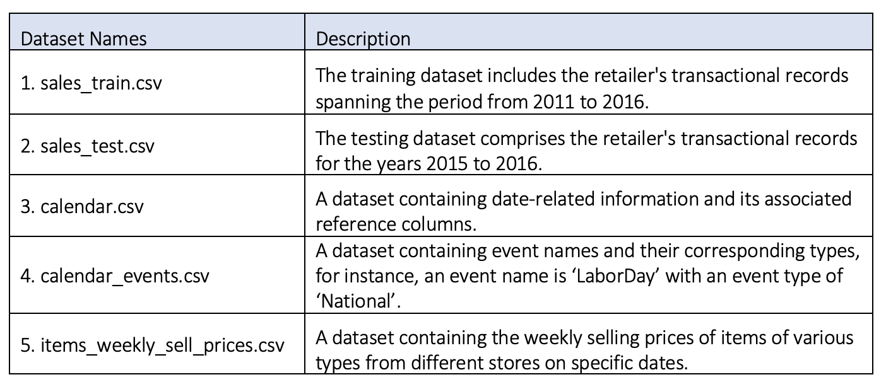

**Data Limitations:**

* Lack of Metadata: The dataset lacks metadata or detailed descriptions of variables and their meanings. This limitation required relying on domain knowledge or making anticipations, which can introduce uncertainty into the analysis.
* Limited Store and State Coverage: The dataset only includes weekly sell prices for items from two stores, CA_1 and CA_2, out of a total of 10 stores spanning three different states. This limited coverage may raise concerns about data completeness and generalizability to the broader retail environment.
* Unique Identifiers: The presence of unique identifiers, such as product IDs, in the data can pose a challenge. These identifiers may lead to overfitting if not handled carefully. Overfitting occurs when a model learns to memorize specific data points rather than identifying general patterns, which can result in poor predictive performance on new data.
* Ethical Considerations: It is essential to consider ethical data limitations, particularly when handling transactional data. This includes ensuring that customer privacy is respected, and that data usage complies with relevant regulations and guidelines.

Addressing these limitations through appropriate data preprocessing, feature selection, and model training techniques is crucial for building a robust and reliable revenue prediction model.

# Data Preparation

To ensure the quality of the data for modelling, conducted the below activities.

* **Reshaping the training dataset and renaming the attributes.**

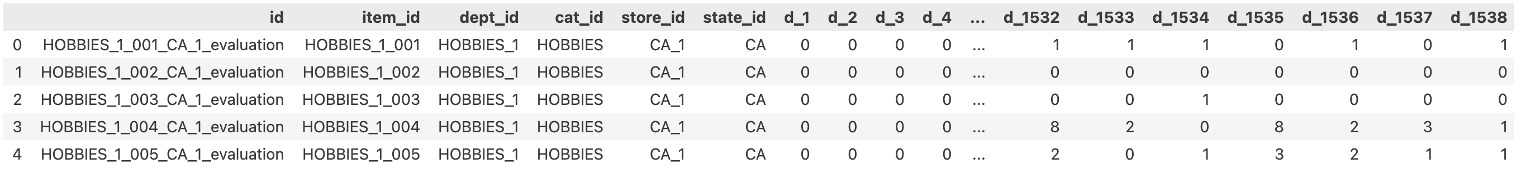

The above training dataset had columns named from d_1 to d_1541 representing the sold item volume for each day for distinct items from 10 stores across 3 separate states. So, melt functionality was utilized to reshape the data to improve attribute organization and for more convenient and suitable data analysis and modelling task.

Additionally, the 'd_*' column was relabeled as 'dayofsale,' and the 'sold item numbers' were renamed as 'volume.

* **Combining the individual datasets into a single dataset.**

Combining data from various sources into a single data frame is a fundamental step in data preprocessing for modelling. It ensures data consistency, enables feature engineering, and simplifies the overall analysis process, ultimately contributing to better decision-making and model performance.

* **Feature Engineering.s**
* Computing the total revenue based on the items sold and the weekly price of an item:
  + Calculating the overall revenue by considering the number of items sold and their corresponding weekly prices was essential for developing the machine learning model to predict target variable revenue.
* Processing the ‘date’ feature to derive additional date related information
* To enhance the dataset's date related information by extracting additional date related features from the 'date' attribute such as day of a week, month, year, and week of the year for a model to learn generalized features.
* Therefore, set the datetime type to the date feature and utilized the datetime functionality to extract the day of the week, month, year, and week of the year information.
* **Selecting appropriate features.**

**Features selected**: 'item_id', 'store_id', 'date', 'event_name', 'event_type', 'revenue'

To build a machine learning predictive model, above specific features were chosen. Due to the presence of duplicate columns after aggregating the datasets, it resulted in the large dataset leading to memory related issues. For instance, ‘store_id’ field values (CA_1, WI_2, TX_9) already incorporates the ‘state_id’ attribute values (CA, WI, TX). Therefore, it's logical to choose pertinent features that have generalized unique values and avoid duplicates.

Additionally, to address the memory challenges associated with analyzing the extensive dataset, the above mentioned features were chosen based on their relevance from a business perspective.

* **Identifying and eliminating identifiers.**

The 'id' attributes serve as unique identifiers for individual items sold within a specific category, store, and state on a particular date. As a result, during the feature selection process, this identifier was omitted.

Including it in the analysis could potentially result in overfitting, where the model becomes too focused to these specific values, rather than capturing the underlying, generalized patterns present in the retailer's data.

* **Splitting data into different datasets.**

To split the dataset into training and validation below strategy was employed.

* Training data: From 2011-01-01 to 2014-12-31
* Validation data: from 2015-01-01 to 2016-12-31

The retail data covers multiple years, and splitting it into training (historical) and validation (future) sets, would maintain the temporal consistency of the dataset. This ensures that the model is trained on past data and tested on more recent data, mimicking a real-world scenario.

Furthermore, this approach aided in handling the relatively compact dataset, mitigating memory-related challenges.

* **Handling and imputing missing values.**

After combining the datasets, missing values were identified in the attributes.

|  |  |
| --- | --- |
| Attribute Name | Total missing values |
| event_name | 43143350 |
| event_type | 43143350 |
| revenue | 12291876 |

To handle missing values in the 'event_name' and 'event_type' features, 'None' was used as a replacement for the missing values.

For address missing values in the 'revenue' target feature, 0 was used for imputation. This signifies days with no items sold and, consequently, zero income.

* **Aggregating the revenues based on the date across all items, stores, and states.**

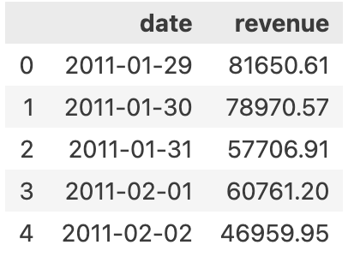

To construct the revenue forecasting model using the Prophet time-series model, aggregated the revenue figures based on the date, encompassing all items, stores, and states.

# Modelling

As a part of the learning process, developed and trained the following regression and time-series models.

* **Predictive Model**

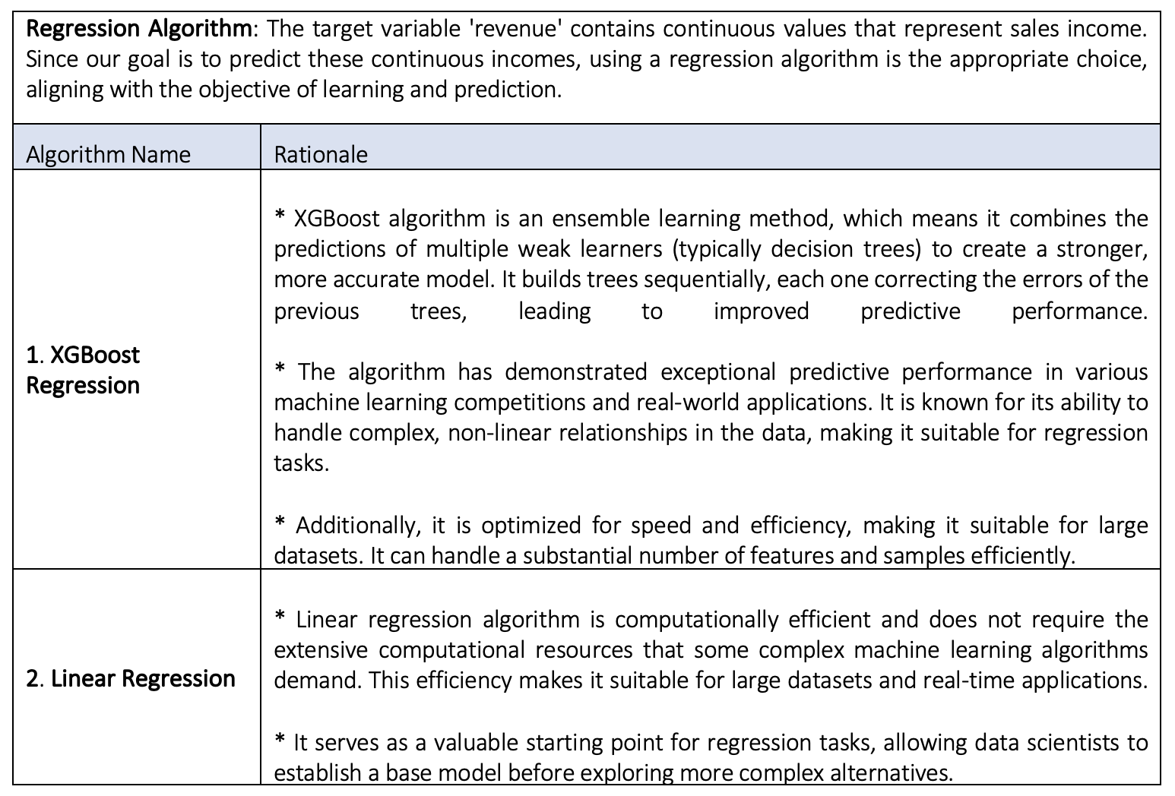

**Pipeline**

The pipeline automates the steps required to preprocess input data, and make predictions as the same preprocessing and prediction steps are consistently applied to incoming data, ensuring that results are reproducible and dependable.

Building a pipeline for model deployment for servicing with an API enhances the model's usability and reliability in using the predictive model in an operational environment.

* **Forecasting Model**

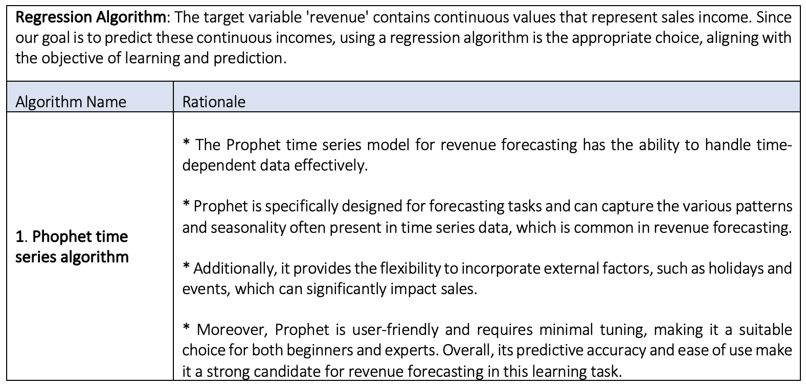

**Employing Holiday Construct of the Phophet algorithm.**

The charts above demonstrate periodic spikes in retail revenue in both directions, with noticeable increases and declines occurring during specific months of the year, following a recurring pattern at certain intervals.

While these spikes could be attributed to various factors, we can hypothesize that they may be related to long weekends, holidays, or significant promotions that the company runs approximately every quarter, potentially impacting the sales revenue.

To leverage this information for more accurate forecasting during those months, utilising Prophet's holiday feature which is a Pandas dataframe containing the holidays and their respective dates.

# Evaluation

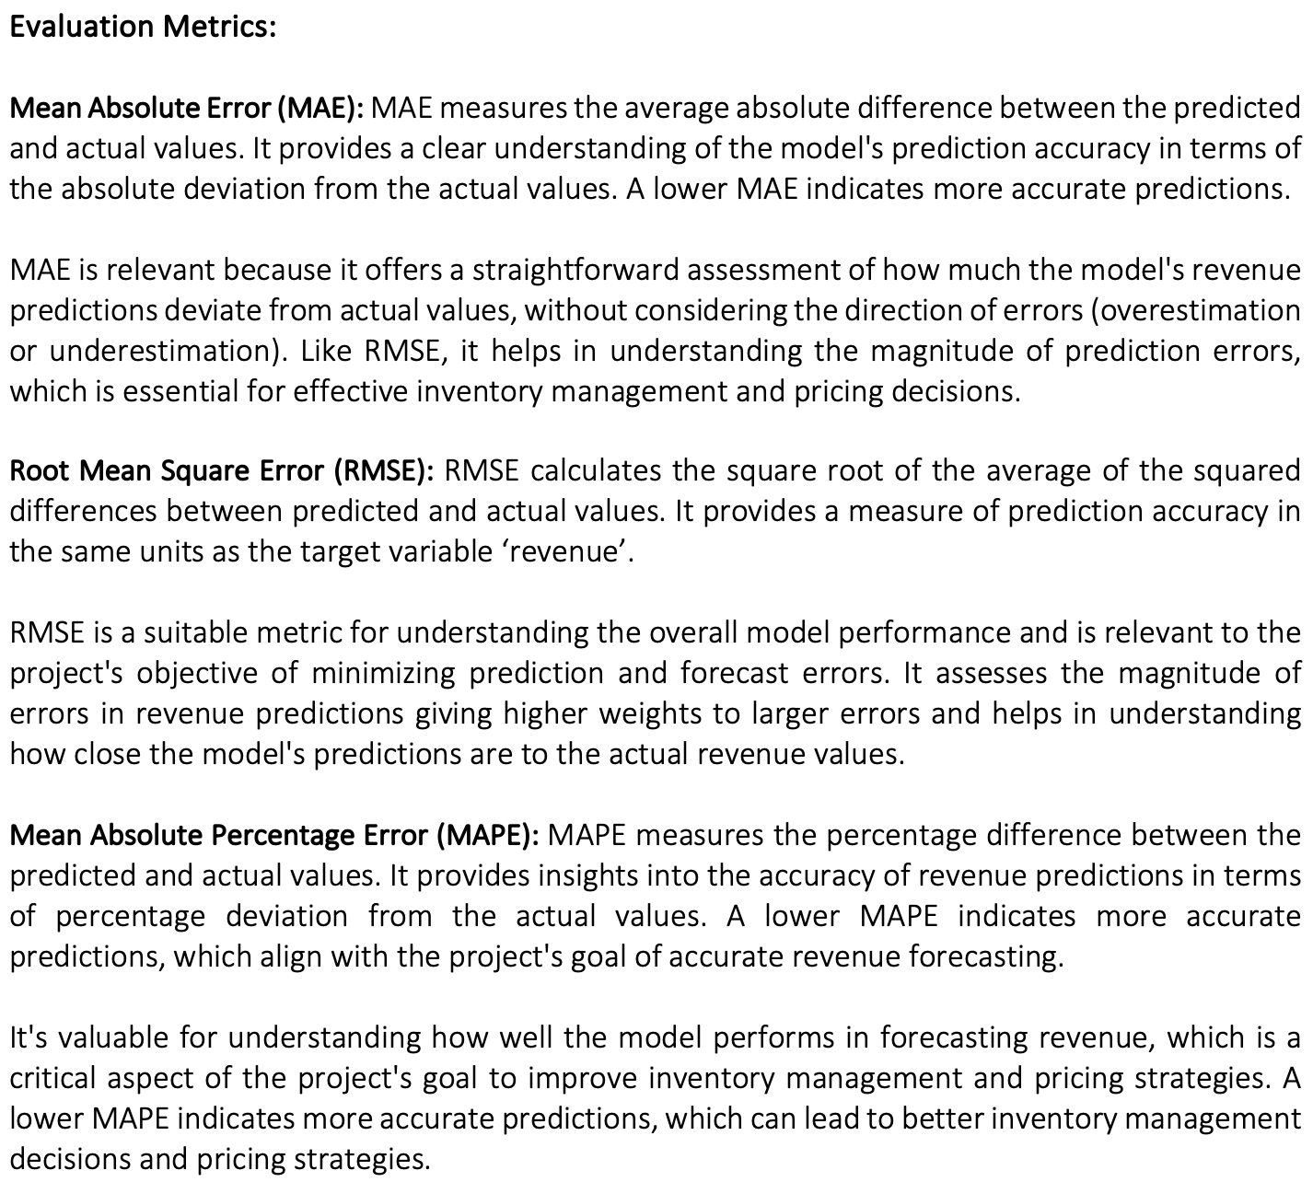

**Results and Analysis:**

* **Predictive Model**

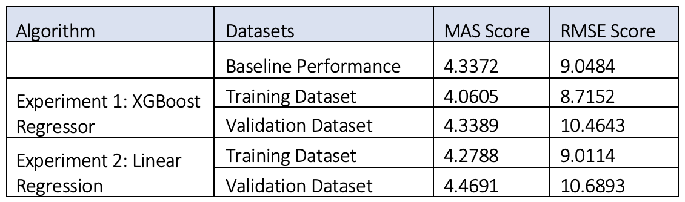

The baseline model has a MAS score of 4.3372 and an RMSE score of 9.0484. This serves as a reference point for evaluating the other models.

**Experiment 1: XGBoost Regressor**

* The XGBoost Regressor algorithm achieves a lower MAS score (4.0605) and RMSE score (8.7152) compared to the baseline on the training data. This indicates that the model provides a better fit to the training dataset.
* However, the model’s performance on the validation dataset, deteriorates slightly, with a slightly higher MAS score (4.3389) and considerably higher RMSE score (10.4643), suggesting that the model is overfitting to the training dataset, as it struggles to generalize to unseen data.

**Experiment 2: Linear Regression**

* The Linear Regression model has a MAS score of 4.2788 and an RMSE score of 9.0114 on the training dataset. It performs slightly worse than the XGBoost Regressor but is still better than the baseline.
* On the validation dataset, the model has a higher MAS score (4.4691) and RMSE score (10.6893) compared to the XGBoost Regressor. Similar to XGBoost model, it also overfitts on the training dataset.
* **Forecasting Model**

The baseline model's MAPE score of 898.0839 indicates that, on average, it predicted sales revenue values with an error of approximately 898%.

The RMSE score of 21278.1704 represents the root mean square error, which measures the square root of the average squared differences between the predicted and actual revenue values. This score is exceptionally elevated, suggesting a significant spread of errors in the baseline model's revenue forecasts.

**Experiment 1: Phophet algorithm**

* The Prophet algorithm’s, MAPE score on the training dataset reduced to 821.0444, indicating that the Prophet algorithm reduced the average prediction error by a significant margin.
* The RMSE score in the training dataset decreased to 10442.7834, signifying a substantial reduction in prediction errors' dispersion.
* The validation dataset showed remarkable results, with an exceptionally low MAPE score of 7.0549. This indicates that, on average, the Prophet algorithm’s predictions deviated by only about 7% from the actual sales revenue values, demonstrating high accuracy.
* The RMSE score in the validation dataset further decreased to 9861.6278, highlighting the effectiveness of the Prophet algorithm in reducing errors in revenue predictions.

Therefore, when evaluating the performance metrics, the predictive model using the XGBoost algorithm, from Experiment 1 indicates slightly superior performance compared to linear regression. It not only outperforms the other models but also exceeds the baseline performance.

As a result, the XGBoost model is selected for model deployment, and the pipeline is constructed using the XGBoost model, while for forecasting, the trained Prophet algorithm was employed as part of the forecasting service via an API.

**Business Impact and Benefits:**

* **Predictive Model**

The XGBoost Regressor model from experiment 1 outperforms the Linear Regression model although it also exhibits overfitting issues. This suggests that the models may have learned specific patterns in the training dataset that do not generalize well to new, unseen data. The impact of overfitting is that the models may make less accurate predictions while servicing in real-world scenarios.

The root causes of model performance issues, such as overfitting, need further investigation. It could be due to insufficient data, or data transformation choices like ordinal encoder. Identifying and addressing these root causes is critical for improving model performance and business outcomes.

Additionally, incorrect predictions can have various impacts on the business such as overstocking or understocking of products, affecting inventory management efficiency, suboptimal pricing decisions, affecting profitability and inefficiencies in staffing and supply chain management.

* **Forecasting Model**

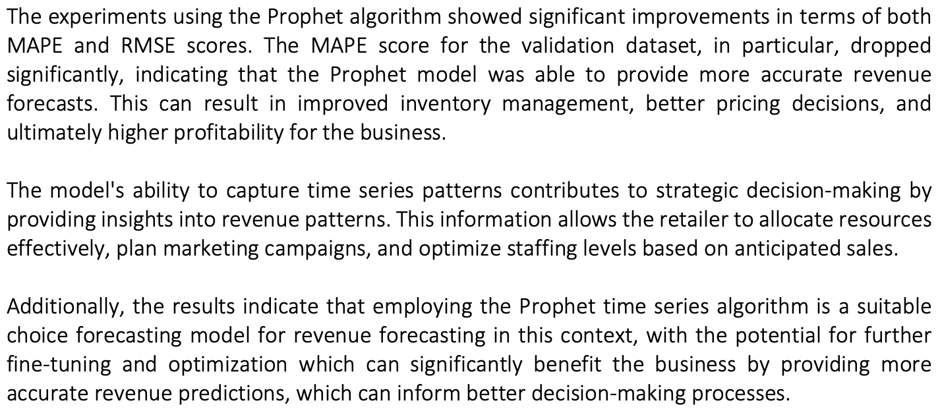

Below are a few risks from a business point of view.

* Overfitting: One of the primary business risks is overfitting, where the model performs exceptionally well on the training data but struggles to generalize to new, unseen data. In the context of revenue prediction, overfitting could lead to inaccurate forecasts when applied to real-world sales data.
* Model Robustness: Business conditions can change over time, and the model should continue to deliver accurate forecasts as market dynamics evolve.
* Data Quality: Another significant business risk is the quality of the data used for training and prediction. Inaccurate, incomplete, or biased data can adversely affect the model's predictions.
* Privacy Concerns: Businesses must handle customer and sales data ethically and in compliance with privacy regulations. Failure to do so can result in legal and reputational issues.

Below are some essential recommendations for the retail business.

* Invest in Data Quality Assurance: Address any data anomalies or inconsistencies promptly to prevent them from affecting predictive models.
* Enhance Data Privacy and Compliance: Implement data encryption, access controls, and auditing to protect sensitive information.
* Continuous Model Monitoring and Improvement: Establish a system for ongoing model monitoring and performance evaluation.
* Incorporate External Data Sources: Incorporate relevant data that can provide insights into market trends and potential sales drivers.
* Ethical AI and Fairness: Establish guidelines for the responsible use of predictive models, including ethical considerations.

**Data Privacy and Ethical Concerns:**

* As the dataset was procured from a university portal for academic purposes, there were no apprehensions related to copyright or privacy infringements.
* Lack of transparency in pricing algorithms can lead to hidden markups or discriminatory pricing. So, it is essential to make pricing algorithms transparent, ensuring customers understand how prices are determined.
* Biased data can lead to unfair predictions, such as discriminatory pricing or targeting. This can harm certain customer groups. So regularly audit data for bias, correct imbalances, and employ fairness-aware algorithms to ensure equitable outcomes.
* Retail businesses collect customer data for various purposes, including sales forecasting. There's a risk of privacy breaches and data misuse. Therefore, implement strong data encryption, access controls, and anonymization techniques.

# Deployment

Deploying a machine learning model involves several below steps to ensure it can be used in the operational environment.

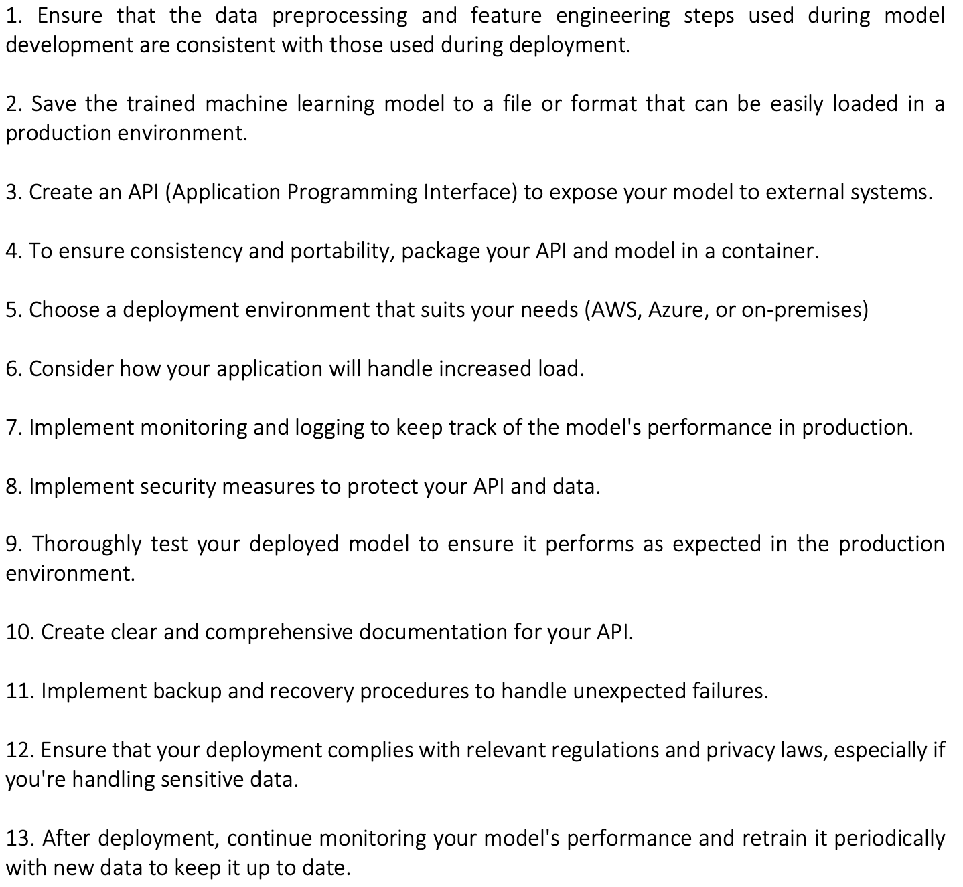

# Conclusion

In conclusion, this project aimed to develop predictive (XGBoost) and forecasting (Phophet) models for sales revenue in a retail setting. Models were successfully deployed as APIs, providing real-time predictions and forecasts to enhance the overall retail business profits and success.

The project achieved its primary goal by delivering predictive and forecasting models for sales revenue. Stakeholder requirements, including those of retail managers and pricing analysts, were met with user-friendly interfaces providing real-time predictions and forecasts to enhance the overall retail business profits and success.

Further, I would experiment with the XGBoost regressor with hyperparameters like max_depth, subsample, max_leaves etc. to improve their predictive performance for better model generalization. And explore other time series models namely SARIMA.

# References

So, A., & Tith, R. (2023, September 7). Model Optimisation [Lab]. <https://colab.research.google.com/drive/1pq9ncvqjzI0GAr830b5kWZsT9Q4GuBvB>

So, A., & Tith, R. (2023, September 7). Model Optimisation [Lecture]. <https://docs.google.com/presentation/d/1QHwfDMJVDTolb7-TGx46Pt738SunE6W6RvFz5xidz-4/edit#slide=id.gb753713d85_0_643>

So, A., & Tith, R. (2023, September 14). Model Deployment [Lab]. <https://docs.google.com/presentation/d/1VZHvfQ3zBBRsfA90-oEjFwhZ6sSJrm-Hqrf_7_6r6BE/edit#slide=id.gb753713d85_0_643>

So, A., & Tith, R. (2023, September 14). Model Deployment [Lecture]. <https://colab.research.google.com/drive/1Qv7MzKCzDMskH2kR_qletXwZLLyzFrts#scrollTo=CcBG6EMNkNjr>

(n.d.). XGBoost Tutorials. XGBoost. Retrieved October 7, 2023, from <https://xgboost.readthedocs.io/en/stable/tutorials/index.html>

Brownlee, J. (2021, March 7). XGBoost for Regression. Machine Learning Mastery. Retrieved October 6, 2023, from <https://machinelearningmastery.com/xgboost-for-regression/>

Brownlee, J. (2020, May 8). Time Series Forecasting With Prophet in Python. Machine Learning Mastery. Retrieved October 4, 2023, from <https://machinelearningmastery.com/time-series-forecasting-with-prophet-in-python/>

(n.d.). FastAPI. FastAPI. Retrieved October 8, 2023, from <https://fastapi.tiangolo.com>

Shah, A. (2023, July 25). FastAPI Handbook – How to Develop, Test, and Deploy APIs. FastAPI. Retrieved October 9, 2023, from <https://www.freecodecamp.org/news/fastapi-quickstart/>